**Lesson07 using Azure Command Line Interface**

**Notes: -**

**1-The Azure command-line interface (Azure CLI) is a set of commands used to create and manage Azure resources. The Azure CLI is available across Azure services and is designed to get you working quickly with Azure, with an emphasis on automation.**

**2-you can install azure command line interface on your desktop or use Azure PowerShell from the Azure dashboard itself**

**(You have to create Azure Storage account for the Azure PowerShell)**

**3-we apply the following commands on Azure PowerShell**

**Commands: -**

**Az login**

**Az group create --name vm-grp --location eastus**

**Az vm create --resource-group vm-grp --name demovm --image win2019datacenter**

**--admin-username azureuser**

**Section02 Using Azure PowerShell**

**Notes: -**

**1-azure PowerShell is cross-platform task automation solution make up of a command-line shell, scripting language, and configuration management framework, can run on cross platform such as windows, Linux, macOS**

**2-you have on the Azure power shell to create storage account to apply these commands**

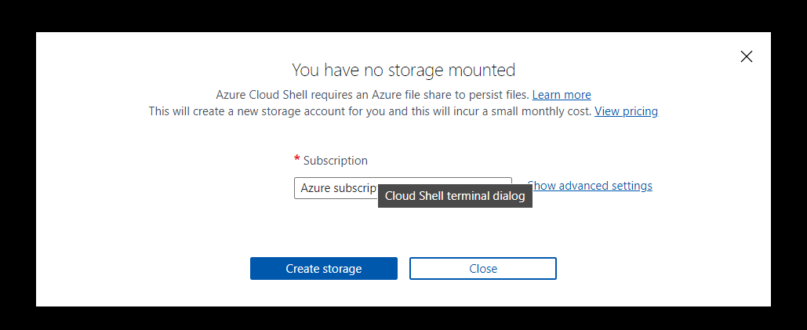

**Commands: -**

**//to create new resource group on location east us**

**New-AzResourceGroup -Name new-vm-grp -Location EastUS**

**//to create virtual machine under the resoruce gropu with set security gropu and open two port 80,3389**

**New-AzVm -ResourceGroupName "new-vm-grp" -Name "demovm1" -Location "East US" -VirtualNetworkName "demo-network"**

**-SubnetName "subnetA" -SecurityGroupName "myNSG" -PublicIpAddressName "new-ip" -OpenPorts 80,3389**